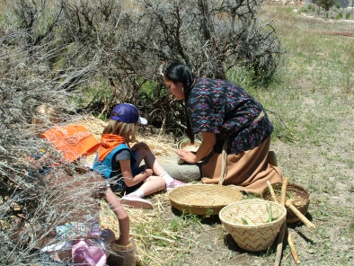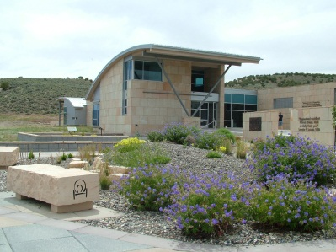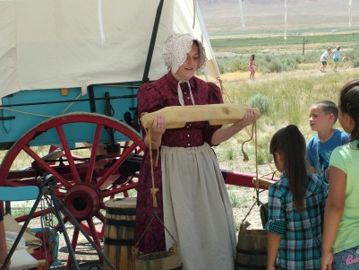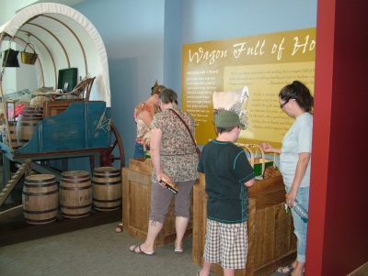

Site Name: California Trail Interpretive Center (CTIC) – Elko, Nevada

Site Contact: Thomas Valencia (Email: tvalencia@blm.gov / Phone: 775-738-1849)

Program Overview The California Trail Interpretive Center is recruiting a Teacher on the Public Lands candidate for summer 2023! The CTIC interprets the California Experience, its related themes and provides educational and cultural enrichment to the public including K-12 school youth.

The Teacher on the Public Lands (TPL) program provides professional development experiences for teachers by placing them as teacher “interns” at BLM sites the summer where they will perform tasks depending on the educational needs of the site. The internship will last for eight weeks between June & August 2023 for a total of 160 hours at the discretion of the teacher schedule.

The teacher will receive a $3,000 professional development stipend (to be issued at the end of the TPL season), paid tuition for a University of Colorado – Denver three credit hour graduate course, and a once in a lifetime experience promoting hands on learning through some of the United States’ most treasured cultural and natural resources.

Project Information: The project goal is to redevelop grade specific classroom programming to be utilized for grades K-5 for in-person and virtual programs. These will be in alignment with the newly revised 2018 Nevada Academic Content Standards for Social Studies (NVACS).

- Teacher will collaborate on creative methods for classroom engagement along with associated multimedia (powerpoint, virtual trail visit)
- Subjects to be covered include flora/fauna, Native American and emigrant subjects
- Final product will be six in-person classroom lessons (K-5), recorded video material including Elko area trail visits and associated supplemental teaching materials (graphics, handouts, worksheets, etc.)

Project Dates: 6/10/23 - 8/31/23 (Dates negotiable based on applicant availability)

Project Location: Most of the project work can be completed remotely, but the candidate must be able to travel to the CTIC for site orientation and agreed upon program dates. The candidate may also be invited to visit locations along the California National Historic Trail for orientation purposes. Regular meetings will be held virtually to collaborate on materials and assist with project progress.
Housing Availability: None
Stipend: $3000.00 upon completion of program and graduate course requirements
Graduate Credit: 3 graduate credit hours through University of Colorado Denver

Program Hourly Requirements: Total of 160 hours of effort focused on an educational project, the TPL teacher may spend up to 30% of this time experiencing BLM operations, working with the public and learning about the work of the different divisions of the BLM.

Desired Qualifications:
- Experience developing elementary curriculum in accordance with all applicable Nevada Academic Content Standards
- Experience creating hands-on, interactive content
- Ability to work with the public and conduct public speaking in front of groups of up to 40 participants
- Ability to travel to California Trail Interpretive Center in Elko, NV

Application
Applicant Name:
Home Address:
Contact Phone:
Email Address:

Applicant’s School Name:
School District/State:
School Address:
Grade level and subject(s) taught:

- Do you teach at a Title I school? (Please circle) No Yes
If yes, what percentage of your students qualify for Free and Reduced-Price Lunches?

- Can you commit to approximately 8 weeks of time (160 hours) during the summer season (June-August, depending on site needs)? Yes / No

- Describe your most effective unit or lesson plan that actively engaged students in learning. Why was it successful?

- Why do you want to participate in the Teacher on Public Lands program?

- How will you use your experience to enrich your classroom teaching and create opportunities for your students to connect to public lands?

- How will you share information and skills acquired through this experience with your school and district colleagues?

- Describe your familiarity and experiences with local, state or national public lands.

Please provide information for two professional references:
Reference 1:
Name:
Phone Number:
Email Address:
Relationship to applicant:

Reference 2:
Name:
Phone Number:
Email Address:
Relationship to applicant

